Chapter Three

CRISP-DM
Cross-Industry Standard Process
For Data Mining

3.1 : Introduction
The methodology of the implementation of data mining into operational business processes based on approaches to BI implementations, on a methodological framework to business process renovation and IS development, and according to the experiences in the implementation of data mining in analytical business process, a methodology are proposed for the implementation of data mining into operational business processes.
The main elements of the propose are:
- Business case assessment.
- DM readiness assessment.
- Business process renovation.
- CRISP-DM as the methodology used for DM itself.
There is a Cross-Industry Standard Process for Data Mining (CRISP-DM) widely used by industry members. This model consists of six phases intended as a cyclical process: [4]

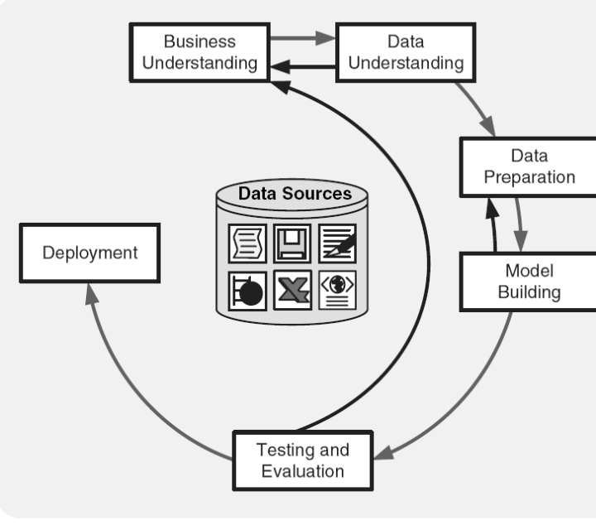
Figure (3.1): CRISP-DM life cycle [4]

Business Understanding :
Project objectives and requirements understanding, data mining problem definition.
Data Understanding :
Initial data collection and familiarization, data quality problems identification.
Data Preparation :
Table, record and attribute selection, data transformation and cleaning.
Modeling :
Modeling techniques selection and application, parameters calibration.
Evaluation :
Business objectives & issues achievement evaluation.
Deployment :
Result model deployment, repeatable data mining process implementation.
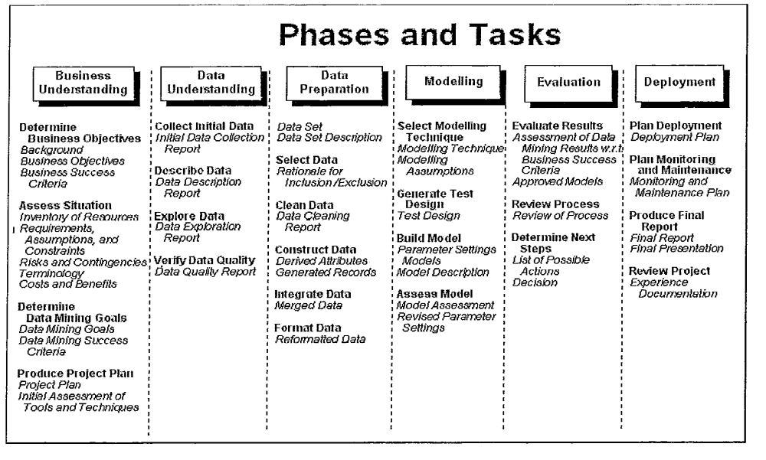
Figure (3.2): CRISP-DM phases and tasks [4]
3.1.1 : Business Understanding
The key element of a data mining study is knowing what the study is for. This begins with a managerial need for new knowledge, and an expression of the business objective regarding the study to be undertaken. Goals in terms of things such as “What types of customers are interested in each of our products?” or “What are typical profiles of our customers, and how much value do each of them provide to us?” are needed. Then a plan for finding such knowledge needs to be developed, in terms of those responsible for collecting data, analyzing data, and reporting. [4]
At this stage, a budget to support the study should be established, at least in preliminary terms. In customer segmentation models, such as Fingerhut’s retail catalog business, the identification of a business purpose meant identifying the type of customer that would be expected to yield a profitable return. The same analysis is useful to credit card distributors. For business purposes, grocery stores often try to identify which items tend to be purchased together so it can be used for affinity positioning within the store, or to intelligently guide promotional campaigns. Data mining has many useful business applications, some of which will be presented throughout the course of the book. [4]
3.1.2 : Data Understanding
Since data mining is task-oriented, different business tasks require different sets of data. The first stage of the data mining process is to select the related data from many available databases to correctly describe a given business task. There are at least three issues to be considered in the data selection. The first issue is to set up a concise and clear description of the problem. Spending behaviors of female shoppers who purchase seasonal clothes. Another example may seek to identify bankruptcy patterns of credit card holders. The second issue would be to identify the relevant data for the problem description. Most demographical, credit card transactional and financial data could be relevant to both retail and credit card bankruptcy projects. [4]
However, gender data may be prohibited for use by law for the latter, but be legal and prove important for the former. The third issue is that selected variables for the relevant data should be independent of each other. [4]
Variable independence means that the variables do not contain overlapping information. A careful selection of independent variables can make it easier for data mining algorithms to quickly discover useful knowledge patterns. Data sources for data selection can vary. Normally, types of data sources for business applications include demographic data (such as income, education, number of households, and age), socio-graphic data(such as hobby, club membership, and entertainment), transactional data(sales records, credit card spending, issued checks), and so on. The data type can be categorized as quantitative and qualitative data. Quantitative data is measurable using numerical values. It can be either discrete (such as integers) or continuous (such as real numbers). Qualitative data, also known as categorical data, contains both nominal and ordinal data. Nominal data has finite non-ordered values, such as gender data which has two values: male and female. Ordinal data has finite ordered values. For example, customer credit ratings are considered ordinal data since the ratings can be excellent, fair, and bad. Quantitative data can be readily represented by some sort of probability distribution. A probability distribution describes how the data is dispersed and shaped. For instance, normally distributed data is symmetric, and is commonly referred to as bell-shaped. Qualitative data may be first coded to numbers and then be described by frequency distributions. Once relevant data are selected according to the data mining business objective, data preprocessing should be pursued. [4]
3.1.3 : Data Preparation
The purpose of data preprocessing is to clean selected data for better quality. Some selected data may have different formats because they are chosen from different data sources. If selected data are from flat files, voice message, and web text, they should be converted to a consistent electronic format. In general, data cleaning means to filter, aggregate, and fill in missing values (imputation). By filtering data, the selected data are examined for outliers and redundancies. Outliers differ greatly from the majority of data, or data that are clearly out of range of the selected data groups. For example, if the income of a customer included in the middle class is $250,000, it is an error and should be taken out from the data mining project that examines the various aspects of the middle class. Outliers may be caused by many reasons, such as human errors or technical errors, or may naturally occur in a data set due to extreme events. Suppose the age of a credit card holder is recorded as “12.” This is likely a human error. However, there might actually be an independently wealthy pre-teen with important purchasing habits. Arbitrarily deleting this outlier could dismiss valuable information.
Redundant data are the same information recorded in several different ways. Daily sales of a particular product are redundant to seasonal sales of the same product, because we can derive the sales from either daily data or seasonal data. By aggregating data, data dimensions are reduced to obtain aggregated information. Note that although an aggregated data set has a small volume, the information will remain. If a marketing promotion for furniture sales is considered in the next 3 or 4 years, then the available daily sales data can be aggregated as annual sales data. The size of sales data is dramatically reduced. By smoothing data, missing values of the selected data are found and new or reasonable values then added. These added values could be the average number of the variable (mean) or the mode. A missing value often causes no solution when a data-mining algorithm is applied to discover the knowledge patterns. [4]
Data can be expressed in a number of different forms. For instance, in CLEMENTINE, the following data types can be used.
RANGE Numeric values (integer, real, or date/time).
FLAG Binary – Yes/No, 0/1, or other data with two outcomes (text, integer, real number, or date/time).
SET Data with distinct multiple values (numeric, string, or date/time).
TYPELESS For other types of data.
Usually we think of data as real numbers, such as age in years or annual income in dollars (we would use RANGE in those cases). Sometimes variables occur as either/or types, such as having a driver’s license or not, or an insurance claim being fraudulent or not. This case could be dealt with using real numeric values (for instance, 0 or 1). But it’s more efficient to treat them as FLAG variables. Often, it’s more appropriate to deal with categorical data, such as age in terms of the set {young, middle-aged, elderly}, or income in the set {low, middle, high}. In that case, we could group the data and assign the appropriate category in terms of a string using a set. The most complete form is RANGE, but sometimes data does not come in that form so analysts are forced to use SET or FLAG types. [4]
Sometimes it may actually be more accurate to deal with SET data types than RANGE data types. Each software tool will have a different data scheme, but the primary types of data dealt with are represented in these two lists. There are many statistical methods and visualization tools that can be used to preprocess the selected data. Common statistics, such as max, min, mean, and mode can be readily used to aggregate or smooth the data, while scatter plots and box plots are usually used to filter outliers. More advanced techniques (including regression analyses, cluster analysis, decision tree, or hierarchical analysis) may be applied in data preprocessing depending on the requirements for the quality of the selected data. Because data preprocessing is detailed and tedious, it demands a great deal of time. In some cases, data preprocessing could take over 50% of the time of the entire data mining process. Shortening data processing time can reduce much of the total computation time in data mining. The simple and standard data format resulting from data preprocessing can provide an environment of information sharing across different computer systems, which creates the flexibility to implement various data mining algorithms or tools. As an important component of data preparation, data transformation is to use simple mathematical formulations or learning curves to convert different measurements of selected, and clean, data into a unified numerical scale for the purpose of data analysis. Many available statistics measurements, such as mean, median, mode, and variance can readily be used to transform the data. In terms of the representation of data, data transformation may be used to transform from numerical to numerical scales, and recode categorical data to numerical scales. For numerical to numerical scales, we can use a mathematical transformation to “shrink” or “enlarge” the given data. One reason for transformation is to eliminate differences in variable scales. [4]
3.1.4 : Modeling
Data modeling is where the data mining software is used to generate results for various situations. A cluster analysis and visual exploration of the data are usually applied first. Depending upon the type of data, various models might then be applied. If the task is to group data, and the groups are given, discriminate analysis might be appropriate. If the purpose is estimation, regression is appropriate if the data is continuous (and logistic regression if not). Neural networks could be applied for both tasks. [4]
Decision trees are yet another tool to classify data. Other modeling tools are available as well. We’ll cover these different models in greater detail in subsequent chapters. The point of data mining software is to allow the user to work with the data to gain understanding. This is often fostered by the iterative use of multiple models. Data mining is essentially the analysis of statistical data, usually using enormous data sets. The standard process of data mining is to take this large set of data and divide it, using a portion of the data (the training set) for development of the model (no matter what modeling technique is used), and reserving a portion of the data (the test set) for testing the model that’s built. In some applications a third split of data (validation set) is used to estimate parameters from the data. The principle is that if you build a model on a particular set of data, it will of course test quite well. By dividing the data and using part of it for model development, and testing it on a separate set of data, a more convincing test of model accuracy is obtained. This idea of splitting the data into components is often carried to additional levels in the practice of data mining. Further portions of the data can be used to refine the model. [4]
3.1.5 : Evaluation
The data interpretation stage is very critical. It assimilates knowledge from mined data. Two issues are essential. One is how to recognize the business value from knowledge patterns discovered in the data mining stage. Another issue is which visualization tool should be used to show the data mining results. Determining the business value from discovered knowledge patterns is similar to playing “puzzles.” The mined data is a puzzle that needs to be put together for a business purpose. This operation depends on the interaction between data analysts, business analysts and decision makers (such as managers or CEOs). Because data analysts may not be fully aware of the purpose of the data mining goal or objective, and while business analysts may not understand the results of sophisticated mathematical solutions, interaction between them is necessary. In order to properly interpret knowledge patterns, it’s important to choose an appropriate visualization tool. Many visualization packages and tools are available, including pie charts, histograms, box plots, scatter plots, and distributions. Good interpretation leads to productive business decisions, while poor interpretation analysis may miss useful information. Normally, the simpler the graphical interpretation, the easier it is for end users to understand. [4]
3.1.6 : Deployment
The results of the data mining study need to be reported back to project sponsors. The data mining study has uncovered new knowledge, which needs to be tied to the original data mining project goals. Management will then be in a position to apply this new understanding of their business environment. It is important that the knowledge gained from a particular data mining study be monitored for change. Customer behavior changes over time, and what was true during the period when the data was collected may have already change. If fundamental changes occur, the knowledge uncovered is no longer true. Therefore, it’s critical that the domain of interest be monitored during its period of deployment. [4]
3.2 : SEMMA
In order to be applied successfully, the data mining solution must be viewed as a process rather than a set of tools or techniques. In addition to the CRISP-DM there is yet another well-known methodology developed by the SAS Institute, called SEMMA. The acronym SEMMA stands for sample, explore, modify, model, assess. Beginning with a statistically representative sample of your data, SEMMA intends to make it easy to apply exploratory statistical and visualization techniques, select and transform the most significant predictive variables, model the variables to predict outcomes, and finally confirm a model’s accuracy. A pictorial representation of SEMMA is given. [4]
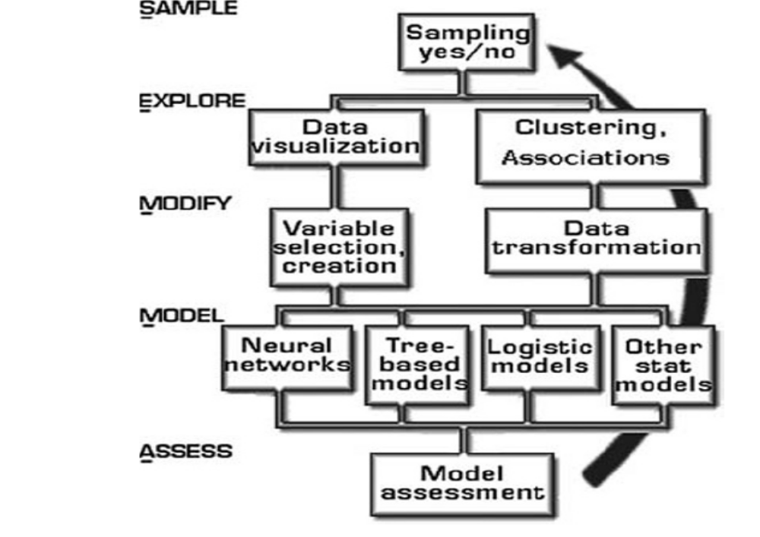
Figure (3.3): SEMMA [4]
By assessing the outcome of each stage in the SEMMA process, one can determine how to model new questions raised by the previous results, and thus proceed back to the exploration phase for additional refinement of the data. That is, as is the case in CRISP-DM, SEMMA also driven by a highly iterative experimentation cycle. [4]
3.3 : Comparison of CRISP & SEMMA
The Nayak and Qiu case demonstrates a data mining process for a specific application, involving interesting aspects of data cleaning and transformation requirements, as well as a wide variety of data types, to include text. CRISP and SEMMA were created as broad frameworks, which need to be adapted to specific circumstances. We will now review how the Nayak and Qiu case fits these frameworks. [4]
Nayak and Qiu started off with a clearly stated set of goals – to develop tools that would better utilize the wealth of data in software project problem reports. [4]
They examined data available, and identified what would be useful. Much of the information from the problem reports was discarded. [4]
SEMMA includes sampling efforts here, which CRISP would include in data preparation, and which Nayak and Qiu accomplished after data transformation. Training and test sets were used as part of the software application. [4]
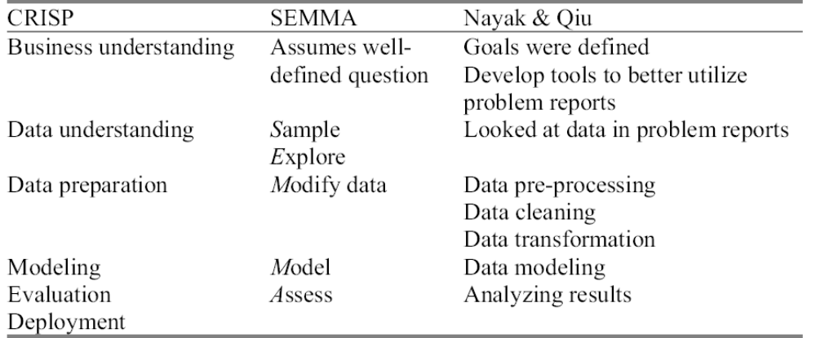
Figure (3.4): Comparison of CRISP & SEMMA [4]

